Order form for Older Men at the Margins resources
- This study explored how men older experience and combat loneliness and social isolation in later life. Using the findings, we've written resources which we hope will be helpful for both older men themselves and people who work with older men:
- Guidance for people working with older men (24-page A5 booklet)
- Ideas for older men on how to beat loneliness and isolation (4-page A5 leaflet)
- A policy briefing paper (4-page A4)
- A postcard to publicise the study and resources, with the url for the Age UK web page where these resources, and other materials including videos, can be found

- The resources are free of charge. Please use them to inform service provision, and distribute postcards and information sheets to older people in your area.

Your name:
Job title (if applicable):
Organisation (if applicable):
Address to post resources (please include full address including postcode):

Number of guidance booklets for practitioners desired (24-page A5 booklet): ____
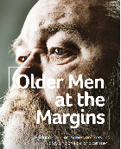
Number of information leaflets for older men desired (4-page A5 leaflet): ____
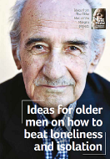 PLEASE TURN OVER
Number of policy briefing papers desired (4-page A4):_____
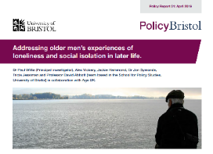

Number of postcards desired (these are good as ‘calling cards’ to use to let people know about the project): ____
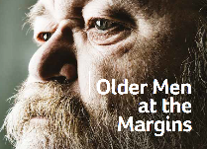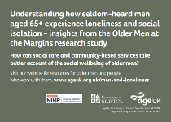

You can download any of the reports, in pdf format, at www.ageuk.org.uk/men-and-loneliness
How are you planning to use these materials (e.g. at a particular event or to display)?

Please return this form to: Margaret Earle via email: Margaret.Earle@ageuk.org.uk
Or post:
Margaret Earle
Influencing Administrative Team
2nd floor, Tavis House
1-6 Tavistock Square
London WC1H 9NA

